INTERGROUP ON GAY AND LESBIAN RIGHTS
EUROPEAN PARLIAMENT

President Barroso
President of the European Commission
Brussels
B1049

Brussels, .. January 2005

Dear Mr. Barroso,

We are writing to you today to bring to your attention recent discriminatory statements made by a member of the new Slovenian Government. On several occasions, including during a hearing before the Slovenian Parliament, Mr. Drobnic, Minister for Labour, Family and Social Affairs, stated that "Homosexuals are a problem for the Ministry of Health" and about same-sex partnerships "Why should the state (...) stimulate non-perfect families?" and "This is not a question of equality, as this means a clear decadence of civilisation". This represents just a few of Mr Drobnic's many homophobic remarks. Over the last few years Mr Drobnic has also expressed intolerant views towards single mothers, Roma and Muslims.

Such statements are not worthy a Government Minister of an EU country and are undermining and defaming the struggle for emancipation of groups that suffer discrimination in Europe.

It is in this regard that I would like to remind you of your own statements at the Plenary Session of the European Parliament, 26 October 2004 in Strasbourg, when you addressed "the importance we [the European Commission] attach to decisive political action by the European Union in the fight against all forms of discrimination", making a personal pledge by saying "I will personally assume full control of our action in the fight against discrimination and the promotion of fundamental rights".

As it is your duty to take decisive action to ensure that Member States and their members of Governments adhere to Treaty obligations, in particular the defence of human rights, we call on you and the other Commissioners in the Fundamental Rights team to address this issue as a matter of urgency.

In our view it is important to send out a strong signal that such statements and behaviour are totally unacceptable. Our concerns are reinforced by the trend adopted by the Slovenian Government of which a clear illustration is the immediate withdrawal of a bill on civil partnership for same-sex relations after its investiture in December 2004. Also statements of MPs show that gay rights are being seen as politically disposable. The statements by the Slovenian Minister and other MPs are inflammatory and encourage and promote discrimination against a law-abiding part of the community. We therefore ask you, are these rights not worth fighting for? We urge you to publicly condemn this kind of discrimination, which conflicts with the content of article 13 of the TEU Treaty, as a signal of your determination to eradicate all forms of discrimination.

We also ask you to call on the Slovenian government to retract homophobic statements and remind its members of the Treaty obligations on protection against discrimination as formulated in article 13.

We urge you to take action and ask for your support. We will also contact your office to arrange a meeting to discuss this important issue.

Yours sincerely,

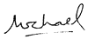

Michael Cashman
President, European Parliament's Intergroup on Gay and Lesbian Rights

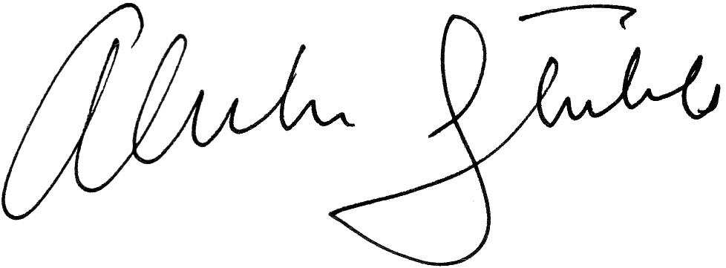
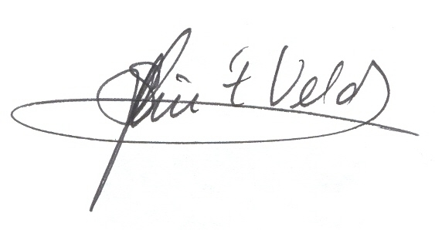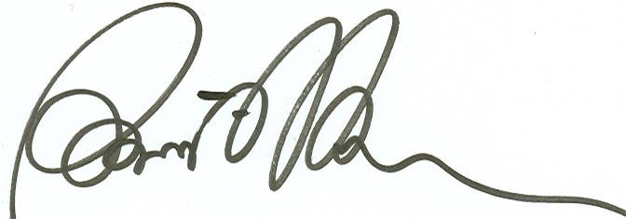

Sophie in 't Veld Raúl Romeva Alexander Stubb

